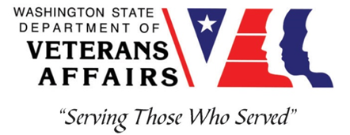
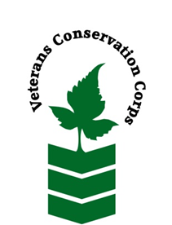

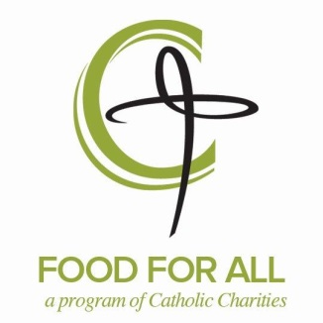

12 E 5th Ave, Spokane, WA 99202
(509) 358-4250
https://www.cceasternwa.org/food-for-all

Veterans Conservation Corps (VCC)
with
CATHOLIC CHARITIES EASTERN WASHINGTON FOOD FOR ALL
WSDA FARM TO FOOD PANTRY

General Description:

Catholic Charities Eastern Washington Food for All seeks an intern to assist with the coordination of our Farm to Community program, which includes Farm to ECE, Farm to Low-income Housing, and Farm to Food Pantry. The Farm to Food Pantry (F2FP) initiative helps bridge the gap between hunger relief organizations and farmers, building relationships through wholesale contracts. If a farmer has a strong relationship with a local food bank, they may be more inclined to make produce donations or provide gleaning opportunities, increasing the amount of nutrient dense produce available to food pantry clients. The initiative is a partnership between Catholic Charities Eastern Washington Food for All, the Washington State Department of Agriculture, Harvest Against Hunger and a cohort of hunger relief organizations across Washington State whose goal is to increase access to healthy fresh foods for food insecure community members.

The CDC reports that Washington residents consume only 12.6 percent of their recommended daily fruit intake, and only 10.9 percent of their recommended daily vegetable intake on average. These disparities can be increased in food pantry patrons who often do not have the luxury of making healthy food choices and may be dependent on what is available through either commodity foods, grocery rescue, or donations. Evidence showing that people who rely regularly on emergency food sources may have inadequate nutritional intake has resulted in greater focus on the nutritional value of foods distributed through food pantries.

The VCC intern will address poverty, food insecurity, and access to healthy fresh foods in Spokane by increasing locally grown produce available at food pantries and low-income housing communities through wholesale contracting and on-farm/farmers market gleaning. The work mainly consists of recruitment, community outreach & development, farmer engagement and produce recovery in order to expand area gleaning capacity.

The VCC intern will work both independently, as well as with the Project Manager and Program Coordinator, and volunteer crews to accomplish organizational goals.

The internship will require up to 40 hours per week, will begin May 1, 2021, and includes a stipend of $1800/month to help cover living expenses.

Schedule:

Tuesday: 9:00am-5:00pm
Wednesday: 7:00am-3:00pm
Thursday: noon-8:00pm
Friday: 9:00am-5:00pm
Saturday: 9:00am-5:00pm
(Schedule may vary due to demands of the season.)

Essential Functions:

Gleaning Coordination
- Conduct community outreach to recruit gleaning volunteers.
- Conduct grower outreach to identify gleaning opportunities.
- Coordinate gleaning efforts at farmers markets.
- Develop/update on-farm gleaning training materials.
- Conduct on-farm gleaning trainings for staff and volunteers.
- Implement and coordinate on-farm gleaning events.
- Document gleaning efforts including number of pounds, harvest location, volunteer hours, and distribution location.
- Develop a sustainability plan for produce recovery.
- Maintain positive relationships with growers, volunteers and donors.
- Deliver gleaned produce to housing communities throughout Spokane County.
F2FP Local Produce Procurement
- Identify and contract with local produce growers.
- Coordinate the receipt of purchased product.
- Document local procurement efforts including type of produce and number of pounds.
- Solicit community donations to increase the produce procurement budget.
- Deliver produce to food pantries throughout Spokane County.

Other Duties:
- Participate in community outreach events and funding events as needed
- Other conservation program and administrative duties assigned by supervisor
- Other duties as assigned by supervisor

Training:

All necessary training required to perform the essential functions/duties is provided on the job.

In addition to on-the-job training, this position may include the following formal trainings and certifications to aid in professional development and job training:

- Veterans Cultural Competency Training
- CPR/First Aid
- Posttraumatic Growth Training
- PTSD/TBI/Mental Health/ Suicide Awareness & Prevention
- WDVA Veteran Peer Corps Certification
- VCC Annual Training (every August)
- Environmental conservation conferences/symposiums/workshops
- Growing your veteran-owned small business
- Whole Farm Planning and Agricultural Entrepreneurship
- Other trainings/certifications as available and desired by intern

Qualifications:

- This position requires the applicant to be a United States military veteran
- Valid Driver’s license
- Experience with Microsoft Word
- Ability to work independently in the field while demonstrating a strong work ethic and safety common sense
- Ability to work as part of a team of staff and/or community volunteers in the field
- Ability to meet and work with new people
- Ability to act as a leader and uphold high ethical standards
- Excellent communication skills
- Excellent attention to detail
- Willingness to learn new skills
- Flexibility and a positive attitude
- Preferred: First Aid training

Physical Requirements:

- Physically able to conduct demanding field work in a variety of weather conditions
- Ability to lift up to 50 pounds

Apply:

All applicants must pass a background check.

To apply to this internship, email a copy of your DD214, a copy of a federal or state issued picture ID, a resume, and a cover letter explaining your interest in this internship to:

Kim Pham
Veterans Conservation Corps Program Specialist
kim@dva.wa.gov

Questions?

To learn more about the Veterans Conservation Corps Internship Program, contact:

Kim Pham
Veterans Conservation Corps Program Specialist
kim@dva.wa.gov

For more information about Catholic Charities Eastern Washington Food For All, contact:
Kendra Dean
Project Manager
kendra.dean@cceasternwa.org
(509)459-6163

Jesse Hansen
Program Coordinator
jesse.hansen@cceasternwa.org
(509)459-6163

