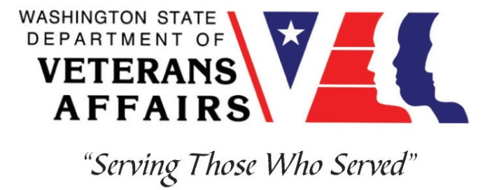
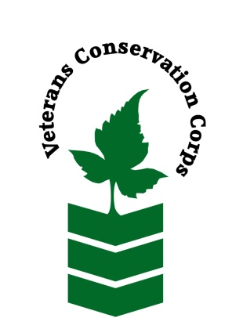
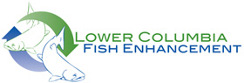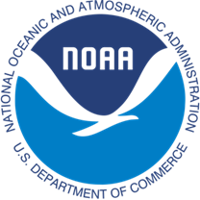

Lower Columbia Fish Enhancement Group, 12404 SE Evergreen Hwy, Vancouver, WA
https://www.lcfeg.org
NOAA WDVA Veterans Conservation Corps Fisheries Internship Program
with the Lower Columbia Fish Enhancement Group

***This position requires the applicant to be a United States military veteran***

Program Description
The NOAA WDVA Veterans Conservation Corps Fisheries Internship Program is a Washington-based internship focused on science and stewardship of fishery resources. Since 2016, NOAA has been funding these internships and partnering with the WDVA Veterans Conservation Corps to deliver high level conservation experiences at NOAA partner organizations throughout Washington. This internship adds the Lower Columbia Fish Enhancement Group (LCFEG) to this NOAA and WDVA Veterans Conservation Corps partnership. The internship will be supervised by LCFEG. The intern will have the opportunity to work in the field, from home, and at LCFEG facilities, with coordination and support provided by the VCC and NOAA.

General Description
This position is with LCFEG based in Vancouver, Washington. LCFEG is a nonprofit conservation group established in 1991, and is one of 14 regional fisheries enhancement groups in Washington that enhance and restore salmon and steelhead habitat. The mission of LCFEG is to promote recovery of self sustaining, naturally spawning salmonid populations and healthy aquatic ecosystems by restoring river and stream habitat, providing nutrients for juvenile fish growth, and engaging the community in hands-on salmon stewardship and education. LCFEG works throughout southwest Washington, including Clark, Cowlitz, Skamania, and Wahkiakum counties with active restoration projects in multiple watersheds across the region.

Aspects of this internship will depend upon the status of COVID-19. In particular, the ability to work directly with individuals in the field and in office settings may be limited until public safety can be assured. In the interim, meetings will be held virtually or with small groups outdoors while implementing proper safety procedures.

Position Description
This position will work collaboratively with LCFEG staff, volunteers, and partners. Tasks will be predominantly field based. The intern will have the opportunity to contribute to on the ground salmon habitat restoration work to increase quality and availability of habitat for ESA-listed salmonids. The intern will learn about salmonid habitat requirements, ecological restoration strategies, fundamentals of river and stream restoration, and native and invasive plant species, and will get to experience some beautiful and often remote headwater reaches.

Tasks will include:

- Operating and maintaining gas-powered and pneumatic hand tools and small engine machinery (e.g., weed whackers, chainsaws, augers, rock and wood drills, etc.);
- Assisting with installation of wood structures in streams;
- Assisting with nutrient enhancement activities, including prepping and loading fish carcasses at hatcheries and tossing them in streams;
- Working on riparian restoration including preparing, planting, monitoring, and maintaining project sites;
- Assisting with habitat monitoring and assessment;
- Working with conservation-minded natural resource professionals focused on salmon recovery, including staff from Washington Dept of Fish and Wildlife, non-governmental organizations, and environmental consulting firms;
- Gaining valuable knowledge, experience, and job skills such as construction logistics, use of a variety of tools and equipment, principles of stream restoration, ecology of salmon and aquatic systems, and plant identification.

Schedule:

This full time 6-month internship will last from July 6, 2021 to January 7, 2022 and includes a VCC stipend of $1800/month (40 hours/week) to help cover living expenses, as well as a supplemental stipend from LCFEG of $900/month.

Due to variable workloads and project timelines, the weekly work schedule can vary from four 10-hour days (about 7 am to 5 pm) to four 9-hour days and a half day to, occasionally, five 8-hour days. Total hours will not exceed 40 per week and no weekend work is anticipated. Alternative hours and flexible scheduling to meet the intern’s needs will be discussed on a case-by-case basis. LCFEG staff do not work on official state holidays, including Labor Day, Veteran’s Day, Thanksgiving and the day after, Christmas, and New Year’s Day. Due to the limited window in which we’re permitted to conduct instream work, we discourage requests for extended vacation from late July to mid-September.

Requirements

- Must be a United States military veteran to be eligible for this position
- Must have a valid driver’s license and dependable transportation to and from the LCFEG office and potentially field sites (mileage reimbursement provided at $0.56/mile for use of personal vehicle if necessary due to COVID-19 restrictions)
- Must enjoy working in an outdoor setting and be comfortable around water

Preferred Qualities

Applicants with the following qualities, knowledge, and abilities will be given preference.

- Motivated, flexible, and positive, with an interest in fisheries conservation, ecological restoration, and/or natural resource management
- Willingness to learn new things and to take direction when needed
- Ability to work independently and as a member of a small crew
- General knowledge of construction and how to safely operate hand and power tools
- Experience driving vehicles while pulling a trailer
- Ability to communicate and interact effectively with a variety of individuals

Physical Requirements:

- Ability to traverse difficult terrain including steep embankments, riparian areas of varying substrate, and on/around large wood while manually transporting equipment and materials
- Ability to perform manual labor outdoors in any weather conditions
- Ability to lift and carry up to 50 lbs

Training

All necessary training required to perform the essential functions/duties is provided on the job.

In addition to on-the-job training, this position may include the following formal trainings and certifications to aid in professional development and job training:
- Veterans Cultural Competency Training
- CPR/First Aid
- Posttraumatic Growth Training
- PTSD/TBI/Mental Health/ Suicide Awareness & Prevention
- WDVA Veteran Peer Corps Certification
- VCC Annual Training (every August)
- Environmental conservation conferences/symposiums/workshops
- Other trainings/certifications as available and desired by intern

Apply

All applicants must pass a background check.

To apply, email a resume, a copy of your DD214, a copy of your current driver’s license, and a cover letter explaining your interest in this internship to:

Kim Pham
Veterans Conservation Corps Program Specialist
kim@dva.wa.gov

Questions?

To learn more about the NOAA WDVA Veterans Conservation Corps Fisheries Internship Program, contact:

Kim Pham
WDVA
Veterans Conservation Corps Program Specialist
kim@dva.wa.gov

John Floberg
NOAA
Marine Habitat Resource Specialist
John.r.floberg@noaa.gov

For more information about LCFEG, contact:

Shauna Hanisch-Kirkbride
Managing Director
Lower Columbia Fish Enhancement Group
Lcfegdirector@outlook.com
360-335-5271

